Minesweeper solving goal-based

intelligent agent using BFS and DFS

Assignment 2 – Artificial Intelligence, KNU Spring semester ‘20

Max Wiersma

2020/04/29

1. Overview of types of intelligent agents
2. Background

Minesweeper is a classic game where the player is to find all squares on a grid that are not mines. It is played on a grid of squares which all start our being hidden. Clicking on a square either reveals the number of mines adjacent to it, or if the square is a mine, the game ends in a loss. If none of the adjacent squares are mines, those squares are recursively revealed too. The aim is to use the information about the number of mines next to the squares to logically deduce where the mines are. The game ends in a win when all non-mine squares have been revealed.

Our implementation\* uses a square n x n grid and 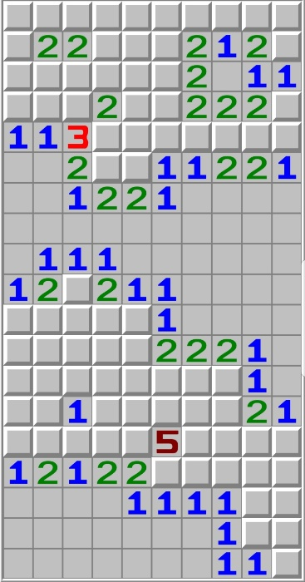m mines, both given as parameters at the start of a game. In most modern versions, including ours, the first click never reveals a mine, in order to decrease the importance of luck.

\*I would like to stress that all (100%) of the code was written by myself.

1. System components

The system consists out of three parts: an implementation of the Minesweeper game, an intelligent agent and an optional web front-end to visualize the agent playing the game.

1. Run environment
2. Agent Algorithm
3. Statistical Analysis
4. Performance Evaluation